Instructions for Lancia D50

- How to open the engine hood:

A. First use the enclosed tweezers to lift its four latches one by one, as shown below:
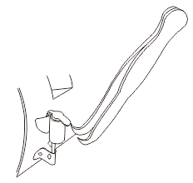
B. Then lift its front edge as shown below. When the engine hood opens about 45⁰ at the front end, it is ready to be removed in an upward direction (see below).
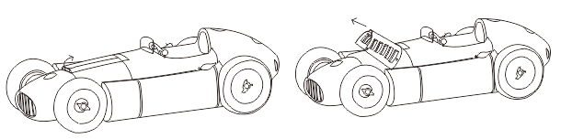

C. Follow steps B and C in a reverse order to mount the engine hood.

- The small rectangular body cover behind the engine hood can be opened (see below).

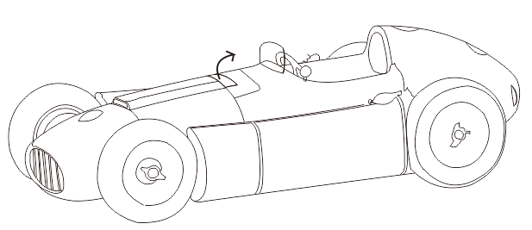
- The flip-open cover over the radiator is functional (see below).

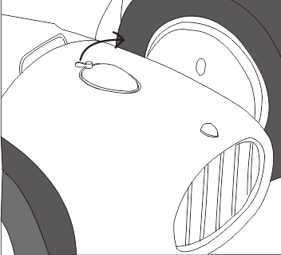

- The flip-open covers over the fuel and oil tanks are also functional (see below).

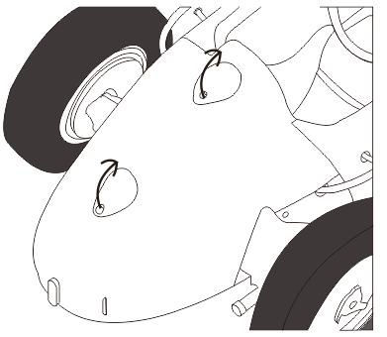

- How to dismount the rear-end body
- Use the enclosed screw-driver to remove the four screws and the rectangular plate carefully from the bottom of the rear-end body, as shown below:

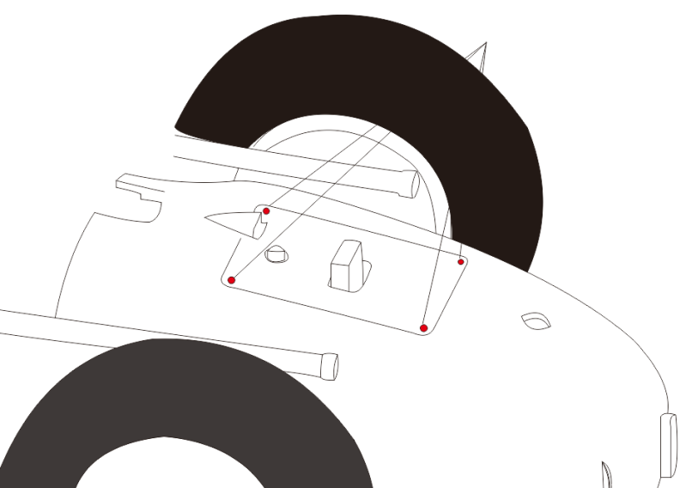
- Continue to remove three more screws from the bottom, as shown below:

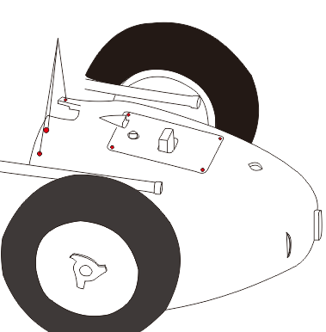

- Now remove two screws from each side of the rear-end body, as shown below:

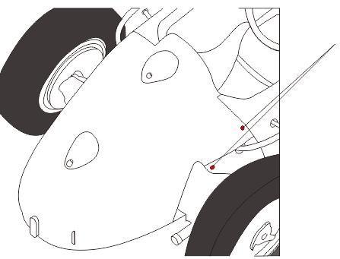

- With all the 11 screws removed, the rear-end body can be detached with a gentle pull backward.

